# Lab: Dictionaries

Problems for in-class lab for the [Python Fundamentals Course @SoftUni](https://softuni.bg/trainings/3450/programming-fundamentals-with-python-september-2021).

Submit your solutions in the SoftUni judge system at <https://judge.softuni.org/Contests/1736>.

## Bakery

*Your first task at your new job is to create a table of the stock in a bakery, and you really don't want to fail on your first day at work.*

You will receive a single line containing some **food** (keys) and **quantities** (values). They will be separated by a **single space** (the **first** element is the **key**, the **second** – the **value,** and so on). Create a **dictionary** with all the keys and values and **print** it on the console.

### Example

|  |  |
| --- | --- |
| **Input** | **Output** |
| bread 10 butter 4 sugar 9 jam 12 | {'bread': 10, 'butter': 4, 'sugar': 9, 'jam': 12} |

### Hint

Let us start with **reading the input** and **creating an empty dictionary**:

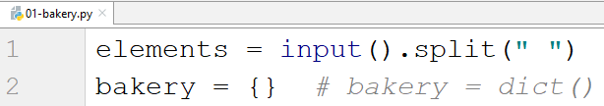

* Note that there are **2 ways** of creating a dictionary (with the **curly braces** or using the **dict()** method).

Since we know that we will get **key-value pairs**, we can use a **for-loop** with **step 2.** We take the **key** and the **value** and **add** them to the dictionary, and after the **loop** **is over,** we **print** it:

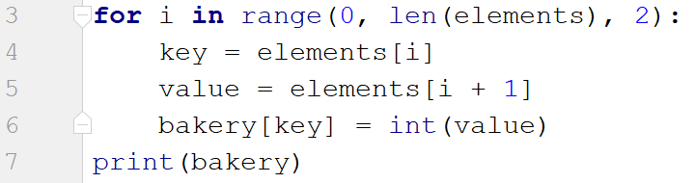

* Note that the **value** must be an **integer** (since it is a **quantity**).

## Stock

*After you have completed your first task, your boss decides to give you another one right away. Now not only you have to keep track of the stock, but also you should answer customers if you have some products in stock or not.*

You will be given **key-value** pairs of **products** and **quantities** (on a single line **separated by space**). On the following line, you will be given products to **search** for. Check for each product. You have **2 possibilities**:

* If you **have the product**, print **"We have {quantity} of {product} left"**
* **Otherwise**, print **"Sorry, we don't have {product}"**

### Example

|  |  |
| --- | --- |
| **Input** | **Output** |
| cheese 10 bread 5 ham 10 chocolate 3  jam cheese ham tomatoes | Sorry, we don't have jam  We have 10 of cheese left  We have 10 of ham left  Sorry, we don't have tomatoes |

### Hint

We repeat the steps from the previous task for reading the products and adding them to the dictionary

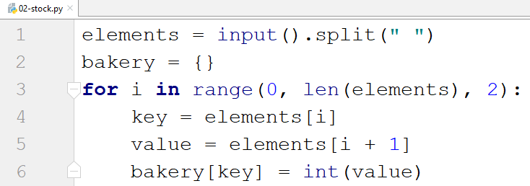

Next, we **read** the products we have to **search** for and **check** for each of them

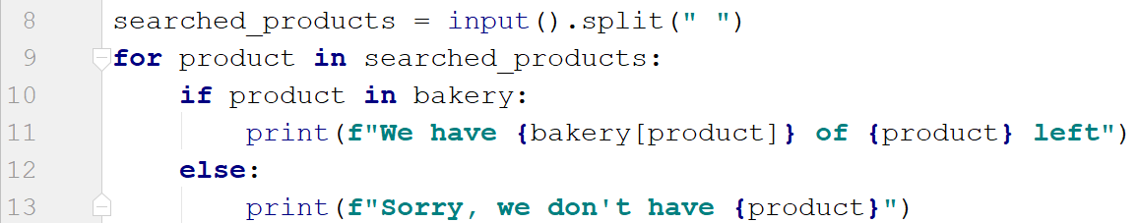

## Statistics

*You seem to be doing great at your first job, so your boss decides to give you as your next task something more challenging. You have to accept all the new products coming in the bakery and finally gather some statistics.*

You will be receiving **key-value** pairs on separate lines separated by **": "** until you receive the command **"statistics"**. Sometimes you may receive a product **more than once**. In that case, you have to **add** the **new quantity** to the existing one. When you receive the **"statistics"** command, print the following:

**"Products in stock:**

**- {product1}: {quantity1}**

**- {product2}: {quantity2}**

**…**

**- {productN}: {quantityN}**

**Total Products: {count_all_products}**

**Total Quantity: {sum_all_quantities}"**

### Example

|  |  |
| --- | --- |
| **Input** | **Output** |
| bread: 4  cheese: 2  ham: 1  bread: 1  statistics | Products in stock:  - bread: 5  - cheese: 2  - ham: 1  Total Products: 3  Total Quantity: 8 |

### Hint

Let us start by **creating** **the dictionary** and creating a **while loop**

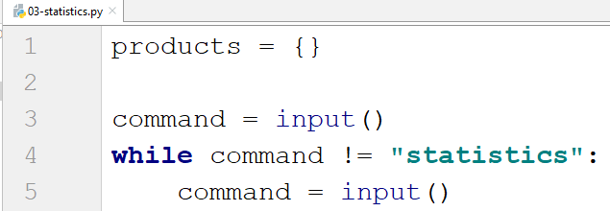

Now, let us get the **product** and the **quantity**

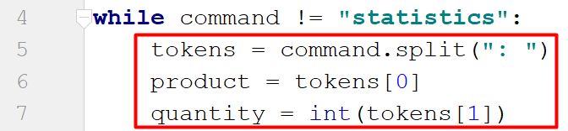

Then, we want to create a **check if** the product is **not already** in the dictionary and set its **value** to **0**

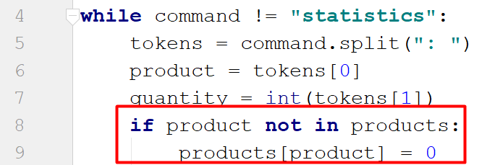

* That way, we make sure that the **product will exist** before we add the **quantity**

Then we **add up the quantity**

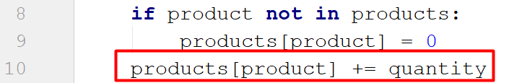

And finally, we **print** the result

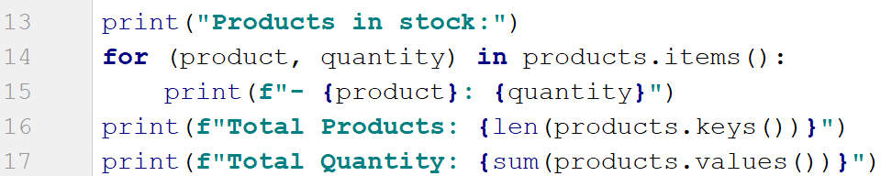

* For the total products, we get the **length of the keys**
* For the total quantity, we **sum the values**

**\***Another way of implementing lines 14 and 15 would be by using **dictionary comprehension**



## Students

You will be receiving names of students, their ID, and a course of programming they have taken in the format **"{name}:{ID}:{course}"**. On the last line, you will receive a name of a course in snake case lowercase letters. You should print only the information of the students who have taken the corresponding course in the format: **"{name} - {ID}"** on separate lines.

***Note: each student's ID will always be unique***

|  |  |
| --- | --- |
| **Input** | **Output** |
| Peter:123:programming basics  John:5622:fundamentals  Maya:89:fundamentals  Lilly:633:fundamentals  fundamentals | John - 5622  Maya - 89  Lilly - 633 |
| Alex:6:programming basics  Maria:7:programming basics  Kaloyan:9:advanced  Todor:10:fundamentals  programming_basics | Alex - 6  Maria - 7 |

## ASCII Values

Write a program that receives a **list of characters** separated by **", "**. It should create a dictionary with each **character** as a **key** and its **ASCII** value as a **value**. Try solving that problem using **comprehension**.

### Examples

|  |  |
| --- | --- |
| **Input** | **Output** |
| a, b, c, a | {'a': 97, 'b': 98, 'c': 99} |
| d, c, m, h | {'d': 100, 'c': 99, 'm': 109, 'h': 104} |

## Odd Occurrences

Write a program that **extracts** **all elements** from a given sequence of words present in it an **odd number of times** (case-insensitive).

* Words are given on a **single line**, space-separated.
* Print the result elements in **lowercase**, in **their order of appearance**.

### Examples

|  |  |
| --- | --- |
| **Input** | **Output** |
| Java C# PHP PHP JAVA C java | java c# c |
| 3 5 5 hi pi HO Hi 5 ho 3 hi pi | 5 hi |
| a a A SQL xx a xx a A a XX c | a sql xx c |

### Hints

**Read** a line from the console and **split it by a space**, and create a **dictionary**:

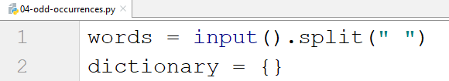

Create a **loop** and check for **each word** (**lower case**) if it is **in the dictionary**, and if it is not, add it:

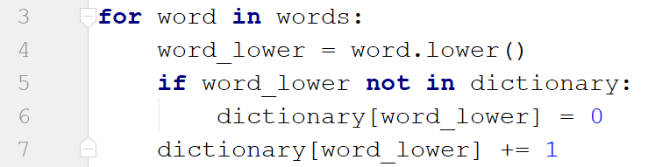

Then create another loop using the **items()** method and check if the **occurrence** of the current word is **odd**

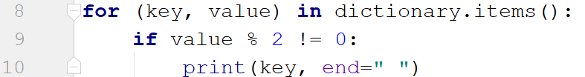

## Word Synonyms

Write a program, which keeps a dictionary with synonyms. The **key** of the dictionary will be the **word**. The **value** will be a **list of all the synonyms of that word**. You will be given a number **n – the count of the words**. After each term, you will be given a synonym, so the count of lines you should read from the console is **2 * n. You will be receiving** a **word** and a **synonym** each on a separate line like this:

* **{word}**
* **{synonym}**

If you get the same word **twice**, just **add the new synonym** to the list.

Print the words in the following format:

**{word} - {synonym1, synonym2 … synonymN}**

### Examples

|  |  |
| --- | --- |
| **Input** | **Output** |
| 3  cute  adorable  cute  charming  smart  clever | cute - adorable, charming  smart - clever |
| 2  task  problem  task  assignment | task – problem, assignment |

### Hint

We start by reading the number **n** and creating the **dictionary with synonyms**:

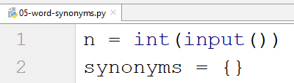

Then we create a **for loop** to read the **word-synonym pairs**:

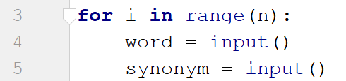

We check if the **word is not** in the dictionary, and in that case, we set its **value to an empty list** (since one word can have **multiple synonyms**), and we **append the new synonym** to that list:

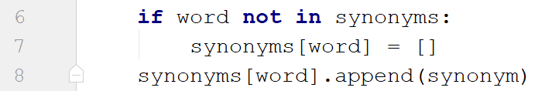

Finally, we **print** the result:

